Project Report on LinkedIn
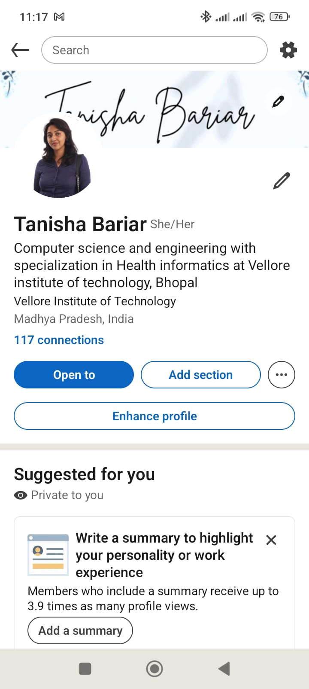
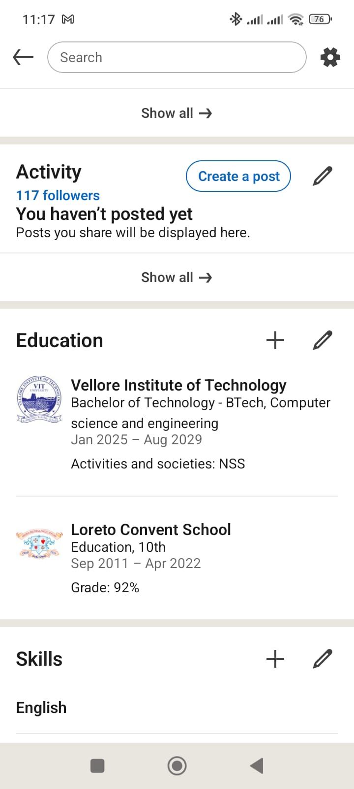1

. Introduction
LinkedIn is a professional networking platform that allows individuals to create profiles, connect with others, and showcase their education, skills, and achievements. It is widely used by students, professionals, and organizations for career development and job opportunities.
This project focuses on understanding LinkedIn and creating a professional profile to build an online presence.

2. Objectives of the Project
- To understand the importance of LinkedIn
- To create a professional online profile
- To showcase educational qualifications and skills
- To learn how to connect and network with professionals
- To improve digital and communication skills

3. About LinkedIn
LinkedIn is a social networking platform designed specifically for professional use. It helps users:
- Build a professional identity
- Connect with industry experts
- Search for jobs and internships
- Share knowledge and achievements
Key Features of LinkedIn
- Profile creation (like an online resume)
- Networking with connections
- Job and internship search
- Posting updates and achievements
- Skill endorsements and recommendations

4. Steps to Create a LinkedIn Profile
Step 1: Sign Up
- Visit www.linkedin.com
- Create an account using email
Step 2: Add Basic Details
- Name and profile photo
- Headline (short description about yourself)
- Location
Step 3: Add Education
- School/College name
- Degree and course
- Duration
Step 4: Add Skills
- Communication skills
- Technical or subject-related skills
Step 5: Build Connections
- Connect with classmates, teachers, and professionals

5. Description of My LinkedIn Profile
The created LinkedIn profile includes the following details:
- Name: Tanisha Bariar
- Course: B.Tech in Computer Science and Engineering
- Specialization: Health Informatics
- Institute: Vellore Institute of Technology, Bhopal
- Education:
  - 10th Grade from Loreto Convent School (92%)
- Skills: English communication
- Connections: 100+ connections
The profile presents a clear and professional introduction along with educational background and skills.

6. Importance of LinkedIn for Students
- Helps in building a professional identity
- Provides job and internship opportunities
- Improves networking skills
- Enhances visibility to recruiters
- Helps in learning from industry experts

7. Learning Outcomes
Through this project, I learned:
- How to create and manage a LinkedIn profile
- Importance of professional online presence
- How to present information effectively
- Basics of networking and communication

8. Conclusion
LinkedIn is a powerful platform for students to grow professionally. Creating a well-structured profile helps in building a strong online presence and opens doors to future career opportunities. This project enhanced my understanding of digital platforms and professional networking.

9. References
- LinkedIn official website
- Online tutorials and guides on LinkedIn usage

